**2.1 Enzymes as Biological Catalysts\***

* Lower the activation energy
* Increase the rate of reaction
* Do not alter the equilibrium constant or the overall ∆G of the reaction
* Are not changed or consumed in the reaction (which means that they will appear and in both the reactants and products)
* Are pH and temperature-sensitive
* Are specific for a particular reaction or class of reactions

Enzyme Classifications

1. Oxidoreductases
   1. Catalyze the oxidation-reduction reactions that involve the transfer of electrons
2. Transferases
   1. Move a functional group from one molecule to another molecule
3. Hydrolases
   1. Catalyze cleavage with addition of water
4. Lyases
   1. Catalyze cleavage without addition of water and without transfer of electrons
   2. Called synthase if they perform the reverse reaction
5. Isomerases
   1. Catalyze the interconversion between isomers, including both constitutional isomers and stereoisomers
6. Ligases
   1. Join two large biomolecules, often of the same type

Impact on Activation Energy

* Exergonic reactions release energy (∆G is negative) while endergonic reactions require energy (∆G is positive)
* Enzymes lower the activation energy and increases the reaction rate (kinetics), but do not alter ∆G or ∆H which affect final equilibrium position (thermodynamics)

**2.2 Mechanisms of Enzyme Activity\***

* Have an active site, which is the site of catalysis
* Act by stabilizing the transition state, providing a favourable microenvironment, or bonding with the substrate molecules

Enzyme-Substrate Binding

1. Lock and Key theory
   1. Enzyme and substrate are exactly complementary
2. Induced fit model
   1. The enzyme and substrate undergo conformational change to interact fully

Cofactors and Coenzymes

* Small non-protein molecules that bind to the active site of the enzyme → participate in the catalysis of the reaction, usually by carrying charge through ionization, protonation, or deprotonation
  + Cofactors: inorganic (minerals)
  + Coenzymes: organic compounds (vitamins)
* Enzymes without cofactors are called **apoenzymes**, while enzymes with cofactors are called **holoenzymes**
* Tightly bound cofactors or coenzymes (e.g. through covalent bond) are called **prosthetic groups**

**2.3 Enzyme Kinetics\***

Kinetics of Monomeric Enzymes

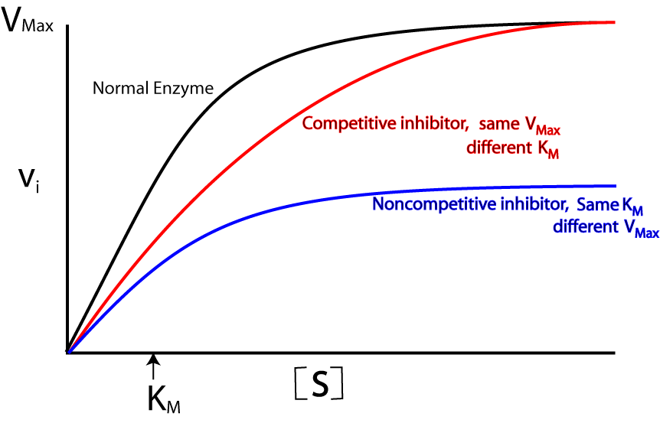

* Let’s say we have 100 stress balls (enzymes) and only 10 frustrated students (substrates) → students relax quickly (reach equilibrium faster)
* Add more students → increase rate of reaction → more students relax in the same amount of time
* Add even more students (close to 100) → less stress balls available → maximum rate of relaxation i.e. saturation

Michaelis-Menten Equation

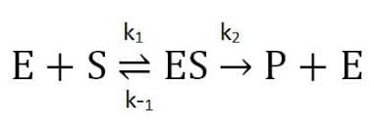

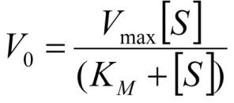

* Sub Vo = 0.5 Vmax → Km = [S]
  + Lower Km means higher affinity for the substrate (low[S] required for 50% enzyme saturation)
* Sub in Vmax = [E] *k*cat
  + at low [S] concentrations

Lineweaver-Burk Plots

* Double reciprocal of the Michaelis-Menten equation
* Useful when determining the type of inhibition because Vmax and Km can be compared without estimation

Cooperativity

* Display a sigmoidal curve because of the change in activity with substrate binding
* Hill’s coefficient
  + More than 1 → positive cooperative binding → increases the affinity of the enzyme for further ligands
  + Less than 1 → negative cooperative binding → decreases the affinity of the enzyme for further ligands
  + Equal to 1 → no cooperative binding

**2.4 Effects of Local Conditions on Enzyme Activity**

Temperature

* As temperature increases, enzyme activity generally increases (doubling approximately every 100C)
* Above body temperature, enzyme activity quickly drops off as the enzyme denatures

pH

* Enzymes are maximally active within a small pH range
* Ionization of the active site changes → protein is denatured → activity drops quickly with changes in pH

Salinity

* Disrupt bonds within an enzyme, causing disruption of tertiary and quaternary structure → loss of enzyme function

**2.5 Regulation of Enzyme Activity**

Feedback Regulation

* A regulatory mechanism whereby the catalytic activity of an enzyme is inhibited by the presence of high levels of a product later in the same pathway

Reversible Inhibition

* Characterized by the ability to replace the inhibitor with a compound of greater affinity or to remove it using mild laboratory treatment

1. Competitive Inhibition
   1. Inhibitor is similar to the substrate and bind at the active site
   2. Can be overcome by adding more substrate
   3. Vmax is unchanged, but Km increases
2. **U**ncompetitive Inhibition (Mnemonic: **U** means both Vmax and Km decrease)
   1. Bind only to the ES complex, and essentially lock the substrate in the enzyme, preventing its release → can be interpreted as increasing affinity between the enzyme and substrate
   2. Bind at an allosteric site (since the ES complex has already formed upon binding); in fact it is the formation of the ES complex that creates a conformational change that allows the uncompetitive inhibitor to bind
   3. Both Vmax and Km decrease
3. **N**oncompetitive Inhibition (Mnemonic: **N** means no change to Km)
   1. Bind to the allosteric site instead of the active site → conformational change
   2. Bind equally well to the enzyme and the ES complex
   3. Vmax decreases (because there is less available enzyme), but Km does not change (because any copies of the enzyme that are still active maintain the same affinity for their substrate)
4. Mixed Inhibition
   1. Inhibitor binds with unequal affinity to the enzyme and the ES complex
   2. Vmax decreases
   3. Km depends, if the inhibitor preferentially binds to the:
      1. Enzyme → increases Km
      2. ES complex → lowers Km

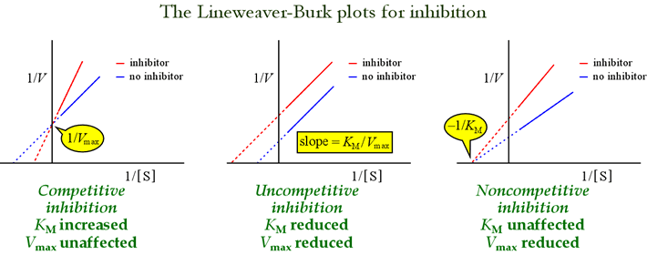

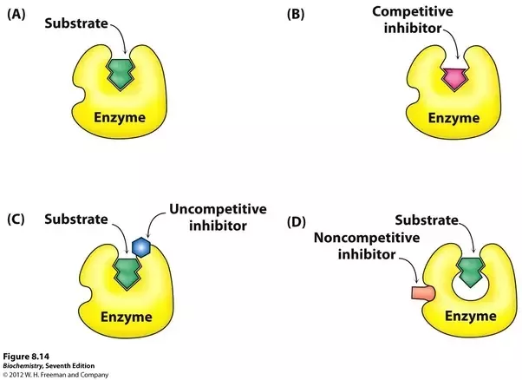

Irreversible Inhibition

* Active site is made unavailable for a prolonged period of time, or the enzyme is permanently altered

Regulated Enzymes

1. Allosteric enzymes (transient)
   1. Allosteric sites can be occupied by activators, which increase either affinity or enzymatic turnover
2. Covalently modified enzymes
   1. Activated or deactivated by phosphorylation or dephosphorylation
   2. Glycosylation can tag en enzyme for transport within the cell, or can modify protein activity and selectivity
3. Zymogens
   1. Precursor of active enzymes → critical that certain enzymes (e.g. digestive enzymes of the pancreas) remain inactive until arriving at their target site
   2. Contain a catalytic (active) domain and regulatory domain, which must either be removed or altered to expose the active domain